1: How does Spring Dependency Injection work internally?
Spring Dependency Injection (DI) is one of the core features of the Spring Framework, and internally it works through the IoC (Inversion of Control) container. Let me break it down step by step:

✅ 1. What is DI in Spring?
Dependency Injection means Spring creates and injects the required objects (dependencies) into your classes, instead of you creating them manually using new.

✅ 2. How does it work internally?
Internally, Spring uses BeanFactory or ApplicationContext (IoC containers) to manage beans.
Here’s the process:

Step 1: Configuration
- You define beans using:
  - XML configuration
  - Java-based configuration (@Configuration, @Bean)
  - Component scanning (@Component, @Service, @Repository)

Step 2: Bean Definition Loading
- Spring reads the configuration and creates BeanDefinition objects (metadata about each bean: class name, scope, dependencies).

Step 3: Bean Creation
- When the container starts, it creates beans using reflection.
- If a bean has dependencies, Spring resolves them by:
  - Constructor Injection (calls constructor with dependencies)
  - Setter Injection (calls setter methods)
  - Field Injection (via reflection for @Autowired)

Step 4: Dependency Resolution
- Spring uses Dependency Lookup internally:
  - It checks the BeanFactory for matching beans by type or name.
  - If multiple beans match, it uses qualifiers or primary bean rules.

Step 5: Lifecycle Management
- After injection, Spring calls lifecycle methods:
  - @PostConstruct
  - InitializingBean.afterPropertiesSet()
  - Custom init methods
- Finally, beans are ready for use.

✅ Key Components
- BeanFactory: Core container for DI.
- ApplicationContext: Advanced container (adds AOP, events, etc.).
- BeanPostProcessor: Allows custom logic before/after bean initialization.
- Reflection: Used to instantiate and inject dependencies.

✅ Internal Flow Diagram
Configuration → BeanDefinition → BeanFactory → Instantiate Bean → Inject Dependencies → Ready Bean
2: Draw a detailed diagram of Spring DI internals
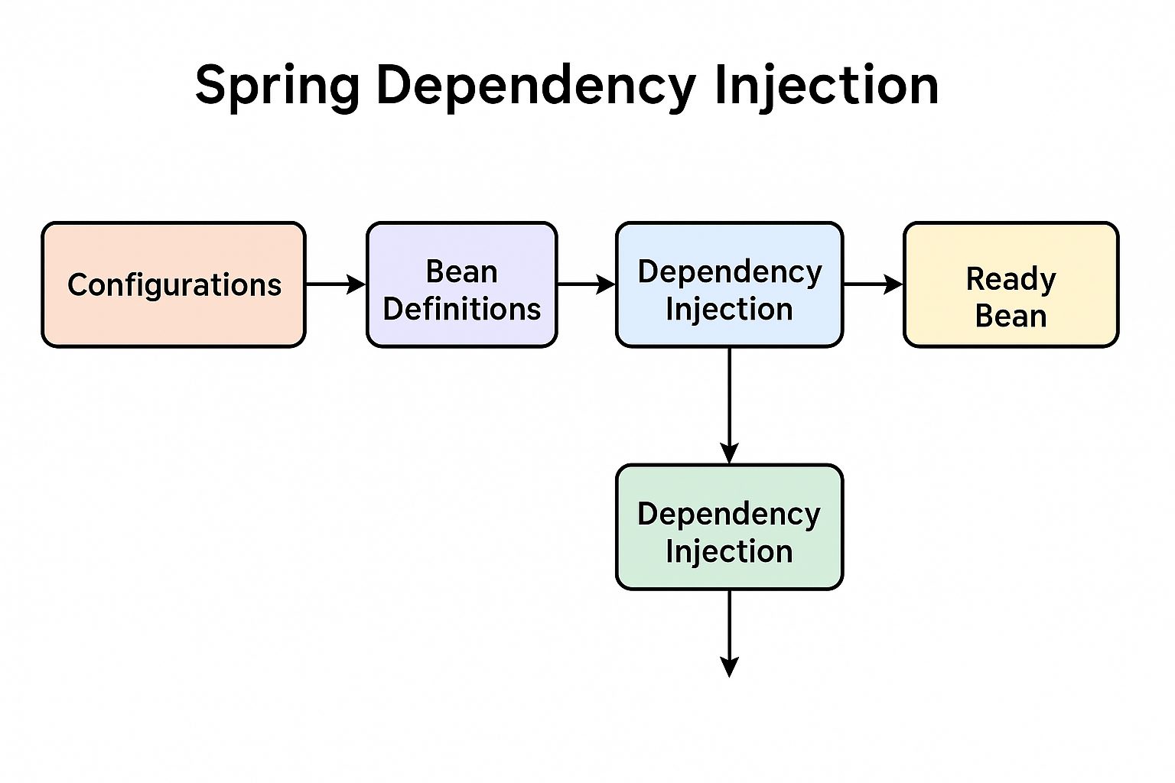
3: what is The Spring Bean Lifecycle?
describes the steps a bean goes through from creation to destruction inside the Spring IoC container. Here’s the complete flow:
✅ 1. Bean Definition Loading
- Spring reads configuration (XML, annotations, or Java config) and creates BeanDefinition metadata.
✅ 2. Bean Instantiation
- Spring creates the bean instance using reflection.
✅ 3. Dependency Injection
- Spring injects dependencies via:
  - Constructor Injection
  - Setter Injection
  - Field Injection (@Autowired)
✅ 4. BeanPostProcessor (Before Initialization)
- Any custom logic before initialization runs here.
✅ 5. Initialization
- If the bean implements:
  - InitializingBean.afterPropertiesSet()
  - Or has a custom init method defined in config
- Spring calls these methods.
✅ 6. BeanPostProcessor (After Initialization)
- Additional custom logic after initialization.
✅ 7. Bean Ready for Use
- The bean is now fully initialized and available in the container.
✅ 8. Destruction
- When the container shuts down:
  - Calls DisposableBean.destroy()
  - Or custom destroy method defined in config.
Lifecycle Diagram
BeanDefinition → Instantiation → Dependency Injection → PostProcess(Before) → Init → PostProcess(After) → Ready → Destroy
4: what are method used Spring bean life cycle ?
In the Spring Bean Lifecycle, several methods and annotations can be used to hook into different stages of the lifecycle. Here’s the complete list:
✅ 1. Constructor
- Called when the bean is instantiated by the IoC container.
✅ 2. Dependency Injection
- Happens via:
  - Setter methods
  - Constructor arguments
  - Field injection (@Autowired)
✅ 3. Initialization Phase
Methods used:
- @PostConstruct
Runs after dependency injection but before the bean is ready.
- afterPropertiesSet()
From InitializingBean interface.
- Custom init method
Defined in @Bean(initMethod="...") or XML <bean init-method="...">.
✅ 4. Post-Initialization
- BeanPostProcessor
Two methods:
  - postProcessBeforeInitialization()
  - postProcessAfterInitialization()
✅ 5. Destruction Phase
Methods used:
- @PreDestroy
Runs before bean is removed.
- destroy()
From DisposableBean interface.
- Custom destroy method
Defined in @Bean(destroyMethod="...") or XML <bean destroy-method="...">.
Lifecycle Summary
Constructor → Dependency Injection → @PostConstruct → afterPropertiesSet() → Custom init → Bean Ready → @PreDestroy → destroy()
5: What is the use of @Transactional? What are the pitfalls?
Great question! @Transactional is one of the most important annotations in Spring for managing transactions. Here’s a detailed explanation:

✅ What is @Transactional?
- It is used to define transaction boundaries in Spring.
- When applied to a method or class, Spring ensures that:
  - The method runs inside a database transaction.
  - If the method completes successfully, the transaction is committed.
  - If an exception occurs, the transaction is rolled back (by default for runtime exceptions).
✅ How it works internally
- Spring uses AOP (Aspect-Oriented Programming) to create a proxy around the method.
- When the method is called:
  - Proxy starts a transaction.
  - Executes the method.
  - Commits or rolls back based on outcome.
✅ Common Pitfalls
- Self-invocation problem
  - If a method annotated with @Transactional calls another method in the same class, the second method won’t be transactional because the proxy is bypassed.
- Wrong exception handling
  - By default, rollback happens only for unchecked exceptions (RuntimeException).
  - Checked exceptions (like SQLException) do not trigger rollback unless configured with rollbackFor.
- Using on private methods
  - @Transactional works only on public methods because proxies operate on interfaces or public methods.
- Not using on beans managed by Spring
  - If the class is not a Spring bean, the annotation does nothing.
- Mixing with async calls
  - If you call a method asynchronously (@Async), the transaction context does not propagate.
- Lazy loading issues
  - If you close the transaction before accessing lazy-loaded entities, you get LazyInitializationException.
✅ Best Practices
- Use @Transactional on service layer methods, not on controllers or DAOs.
- Specify rollbackFor for checked exceptions if needed: @Transactional(rollbackFor = Exception.class)
- Avoid applying it on read-only methods unless you set readOnly = true for optimization: @Transactional(readOnly = true)
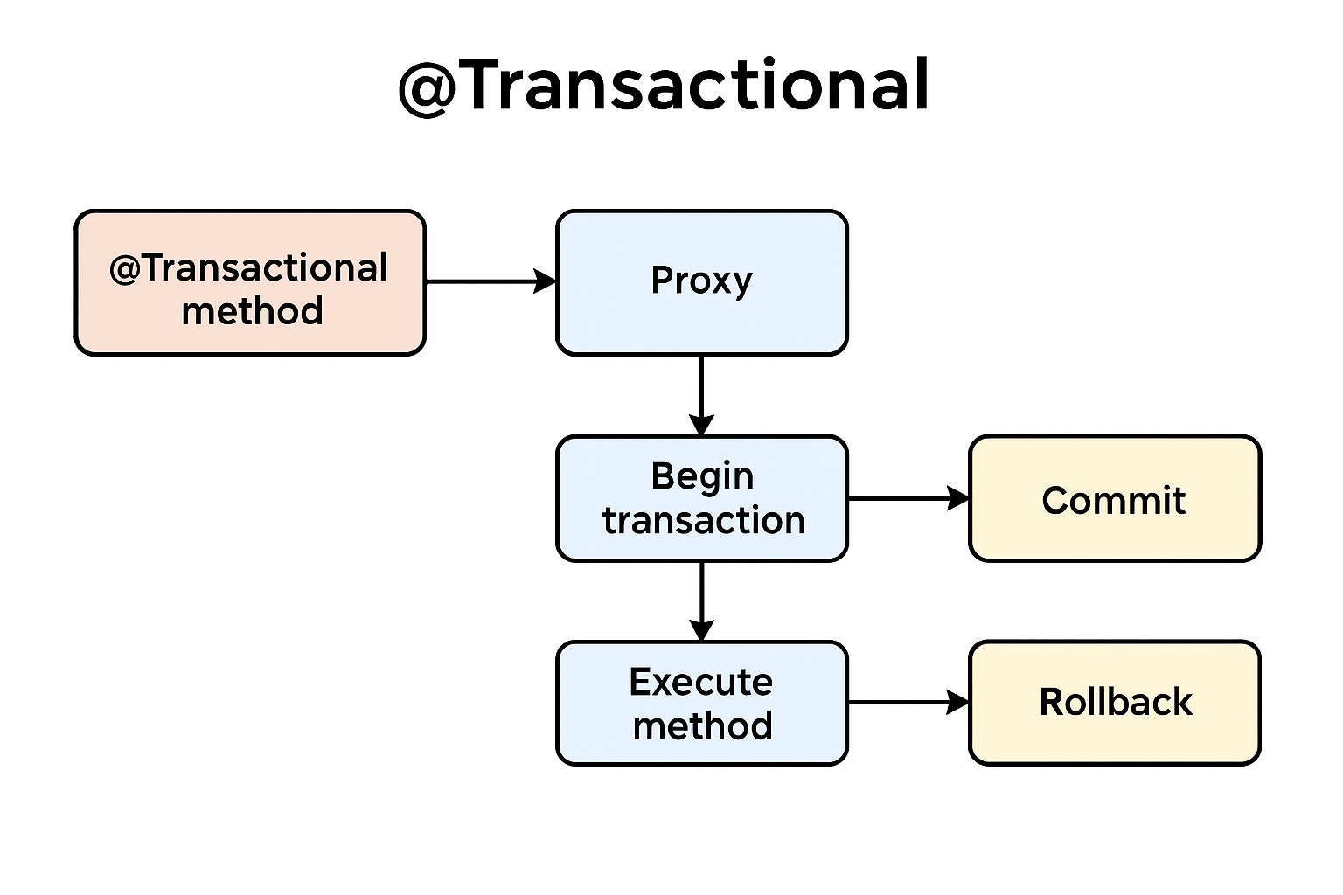
Here’s the @Transactional flow diagram:
- @Transactional method → Spring creates a proxy.
- Proxy begins a transaction before executing the method.
- Executes the method:
  - If successful → Commit.
  - If exception occurs → Rollback (by default for runtime exceptions).
5 : Explain how Spring Boot auto-configuration works?
Spring Boot’s auto-configuration is one of its most powerful features because it reduces boilerplate code and simplifies application setup. Here’s a clear breakdown of how it works:

✅ What is Auto-Configuration?
Auto-configuration automatically configures Spring application components based on:
- Classpath contents (e.g., if spring-webmvc is present, it configures DispatcherServlet).
- Beans already defined in the context.
- Property settings in application.properties or application.yml.
It uses conditional logic to decide what to configure, so you only get what you need.
✅ How Does It Work Internally?
- @SpringBootApplication Annotation
  - Combines @Configuration, @EnableAutoConfiguration, and @ComponentScan.
  - @EnableAutoConfiguration triggers the auto-configuration mechanism.
- spring.factories File
  - Located in META-INF/spring.factories inside Spring Boot JARs.
  - Lists all AutoConfiguration classes under the key: org.springframework.boot.autoconfigure.EnableAutoConfiguration
  - Example: DataSourceAutoConfiguration, WebMvcAutoConfiguration, etc.
- @Conditional Annotations
  - Auto-config classes use conditions like:
    - @ConditionalOnClass → Only configure if a class is on the classpath.
    - @ConditionalOnMissingBean → Only configure if no user-defined bean exists.
    - @ConditionalOnProperty → Configure based on property values.
- Configuration Loading
  - Spring Boot uses AutoConfigurationImportSelector to load these classes dynamically during startup.
✅ Example
If you add spring-boot-starter-web:
- Spring Boot detects DispatcherServlet on the classpath.
- Loads WebMvcAutoConfiguration.
- Configures default beans like RequestMappingHandlerMapping, ViewResolver, etc.
If you define your own WebMvcConfigurer, Spring Boot backs off because of @ConditionalOnMissingBean.
✅ Key Benefits
- Zero boilerplate for common setups.
- Customizable: You can override defaults by defining your own beans or using properties.
- Modular: Auto-config classes are grouped by feature (JPA, Web, Security, etc.).
How to handle exceptions in Spring REST APIs? • @ControllerAdvice, @ExceptionHandler?
Great question! In Spring REST APIs, exception handling is crucial for returning meaningful error responses to clients. The two most common approaches are:

✅ 1. Using @ExceptionHandler in a Controller
- You can define methods inside a controller to handle specific exceptions.
- Annotate the method with @ExceptionHandler(ExceptionType.class).
Example:
@RestController
@RequestMapping("/api")
public class UserController {

@GetMapping("/user/{id}")
public User getUser(@PathVariable int id) {
if (id <= 0) {
throw new IllegalArgumentException("Invalid ID");
}
return new User(id, "John");
}

@ExceptionHandler(IllegalArgumentException.class)
public ResponseEntity<String> handleIllegalArgument(IllegalArgumentException ex) {
return ResponseEntity.badRequest().body(ex.getMessage());
}
}
✔ Handles exceptions locally for that controller.

✅ 2. Using @ControllerAdvice for Global Exception Handling
- @ControllerAdvice allows you to centralize exception handling across all controllers.
- Combine it with @ExceptionHandler for specific exceptions.
Example:
@ControllerAdvice
public class GlobalExceptionHandler {

@ExceptionHandler(IllegalArgumentException.class)
public ResponseEntity<String> handleIllegalArgument(IllegalArgumentException ex) {
return ResponseEntity.badRequest().body("Error: " + ex.getMessage());
}

@ExceptionHandler(Exception.class)
public ResponseEntity<String> handleGenericException(Exception ex) {
return ResponseEntity.status(HttpStatus.INTERNALSERVERERROR)
.body("Something went wrong!");
}
}
✔ Handles exceptions globally for all controllers.

✅ Best Practices
- Return structured error responses (e.g., JSON with errorCode, message, timestamp).
- Use custom exception classes for domain-specific errors.
- Consider ResponseEntityExceptionHandler for extending Spring’s default handling.

What is the difference between RestTemplate, WebClient, and FeignClient?
Here’s a clear comparison of RestTemplate, WebClient, and FeignClient in Spring:

✅ 1. RestTemplate
- Type: Synchronous HTTP client.
- Introduced: Spring 3.
- Usage: Makes blocking HTTP calls (thread waits for response).
- Pros:
  - Simple and widely used.
  - Good for traditional MVC apps.
- Cons:
  - Blocking I/O → Not suitable for reactive programming.
  - Deprecated in favor of WebClient (though still supported).
- Example:
RestTemplate restTemplate = new RestTemplate();
String response = restTemplate.getForObject("https://api.example.com/data", String.class);

✅ 2. WebClient
- Type: Reactive, non-blocking HTTP client.
- Introduced: Spring 5 (part of WebFlux).
- Usage: Ideal for reactive applications (asynchronous).
- Pros:
  - Non-blocking → Better performance under high load.
  - Supports reactive streams (Mono, Flux).
- Cons:
  - Slightly more complex than RestTemplate.
- Example:
WebClient webClient = WebClient.create();
Mono<String> response = webClient.get()
.uri("https://api.example.com/data")
.retrieve()
.bodyToMono(String.class);

✅ 3. FeignClient
- Type: Declarative HTTP client.
- Introduced: Spring Cloud.
- Usage: Simplifies calling REST APIs by using interfaces.
- Pros:
  - No boilerplate code.
  - Integrates with Ribbon, Eureka for microservices.
- Cons:
  - Requires Spring Cloud dependency.
- Example:
@FeignClient(name = "user-service", url = "https://api.example.com")
public interface UserClient {
@GetMapping("/users/{id}")
User getUser(@PathVariable("id") Long id);
}

✅ Summary Table
Feature | RestTemplate | WebClient | FeignClient
Type | Synchronous | Asynchronous | Declarative
Blocking? | Yes | No | Depends on underlying client
Use Case | Simple apps | Reactive apps | Microservices
Introduced | Spring 3 | Spring 5 | Spring Cloud
Explain memory management in Java (Heap, Stack, GC)?
Here’s a clear explanation of memory management in Java, focusing on Heap, Stack, and Garbage Collection (GC):

✅ 1. Java Memory Areas
Java memory is divided into several regions managed by the JVM:
a) Heap Memory
- Purpose: Stores objects and instance variables.
- Shared: Accessible by all threads.
- Divisions:
  - Young Generation: Newly created objects; includes Eden and Survivor spaces.
  - Old Generation: Long-lived objects.
  - Metaspace: Stores class metadata (replaced PermGen in Java 8).
- GC Focus: Most garbage collection happens here.
b) Stack Memory
- Purpose: Stores method calls, local variables, and references.
- Thread-specific: Each thread has its own stack.
- Lifecycle: Memory is freed automatically when a method exits.

✅ 2. Garbage Collection (GC)
- Purpose: Automatically frees memory by removing unused objects from the heap.
- How it works:
  - JVM tracks object references.
  - If an object is not reachable, it becomes eligible for GC.
- Algorithms:
  - Mark and Sweep: Marks reachable objects, sweeps unreferenced ones.
  - Generational GC: Optimizes by focusing on Young Generation first.
- Collectors:
  - Serial GC: Single-threaded (small apps).
  - Parallel GC: Multi-threaded (high throughput).
  - G1 GC: Splits heap into regions for better performance.
  - ZGC/Shenandoah: Low-latency collectors.

✅ Memory Flow Example
public class Example {
public static void main(String[] args) {
int x = 10; // Stored in Stack
Example obj = new Example(); // Object stored in Heap
}
}
- x → Stack
- obj → Heap (reference in Stack)

✅ Key Points
- Heap = Objects (GC managed).
- Stack = Method frames, local variables (auto-managed).
- GC = Automatic cleanup of unused heap objects.
How do you ensure communication between microservices is secure?
Securing communication between microservices is critical in distributed systems. Here are the main strategies:
✅ 1. Use HTTPS (TLS)
- All inter-service communication should happen over HTTPS instead of HTTP.
- TLS ensures encryption in transit, preventing eavesdropping and tampering.
✅ 2. Authentication & Authorization
- OAuth 2.0 / OpenID Connect:
  - Use a centralized Identity Provider (e.g., Keycloak, Okta).
  - Issue JWT tokens for service-to-service calls.
- Mutual TLS (mTLS):
  - Both client and server authenticate each other using certificates.
  - Common in zero-trust architectures.
✅ 3. API Gateway
- Acts as a single entry point for external traffic.
- Handles:
  - Authentication
  - Rate limiting
  - SSL termination
- Examples: Spring Cloud Gateway, Kong, NGINX.
✅ 4. Service-to-Service Security
- Signed JWT tokens for internal calls.
- Service Mesh (e.g., Istio, Linkerd):
  - Provides mTLS automatically.
  - Handles encryption and identity at the network layer.
✅ 5. Secure Configuration
- Never hardcode secrets.
- Use Vault or AWS Secrets Manager for storing credentials.
- Rotate keys regularly.
✅ 6. Network-Level Security
- Deploy services in private subnets.
- Use firewalls and security groups to restrict access.
✅ 7. Validate Input & Output
- Prevent injection attacks.
- Validate all incoming data even from internal services.
✅ Summary
- TLS + JWT + API Gateway + Service Mesh = Strong security foundation.
- Combine transport security, identity, and policy enforcement.
Application context vs bean factory in Spring boot ?
BeanFactory = Basic DI container
ApplicationContext = Advanced container with enterprise features (and the default in Spring Boot).
Auto-Configuration vs Enable Auto Configuring ?
✅ Auto-Configuration
- This is a core feature of Spring Boot.
- It automatically configures beans based on the classpath, existing beans, and property settings.
- Example: If spring-boot-starter-web is on the classpath, Spring Boot auto-configures DispatcherServlet, Tomcat, etc.
- Controlled by @EnableAutoConfiguration (usually included via @SpringBootApplication).
✅ Enable Auto Configuring
- This phrase is not an official Spring Boot term.
- It usually refers to enabling the auto-configuration mechanism, which is done by:
  - Using @EnableAutoConfiguration or @SpringBootApplication.
  - Ensuring spring.factories or META-INF/spring/org.springframework.boot.autoconfigure.EnableAutoConfiguration entries exist.
Key Difference
- Auto-Configuration = The actual process of configuring beans automatically.
- Enable Auto Configuring = The action of turning on that process (via annotations or settings).

